Experiment: 03
Aim: Implement control structures and form validation; create a grading system based on user-entered marks.
Software Required: VS Code (HTML, JS), Google Chrome
Theory:
Control structures in JavaScript are used to control the flow and execution of a program based on specific conditions. They include conditional statements such as if, if-else, and switch, which are used for decision-making, and loops such as for, while, and do-while, which are used to execute a block of code repeatedly. JavaScript also provides break and continue statements to control the execution of loops.
Form validation is the process of checking whether the data entered by a user in an HTML form is correct, complete, and in the required format before it is submitted. JavaScript can be used to validate fields such as name, email, password, age, and phone number by checking conditions and displaying appropriate error messages.
For example, JavaScript can check whether a required field is empty, whether an email follows a valid format, or whether a password meets a minimum length. Form validation improves data accuracy and provides immediate feedback to the user.
1. if Statement
The if statement is used to execute a block of code only when a specified condition is true. If the condition is false, the code inside the if block is skipped. It is commonly used for simple decision-making.
Example:
let age = 20;
if (age >= 18) {
console.log("Eligible to vote");
}

2. if-else Statement
The if-else statement is used when there are two possible outcomes. If the given condition is true, the if block is executed; otherwise, the else block is executed.
Example:
let marks = 45;
if (marks >= 40) {
console.log("Pass");
} else {
console.log("Fail");
}
3. switch Statement
The switch statement is used to select one block of code from multiple possible choices. It compares an expression with different case values and executes the matching case. The break statement is generally used to stop execution from continuing into the next case.
Example:
let day = 2;
switch (day) {
case 1:
console.log("Monday");
break;
case 2:
console.log("Tuesday");
break;
case 3:
console.log("Wednesday");
break;
default:
console.log("Invalid day");
}
4. for Loop
The for loop is used when the number of repetitions is known or can be determined in advance. It generally contains three parts: initialization, condition, and increment/decrement.
Example:
for (let i = 1; i <= 5; i++) {
console.log(i);
}
5. while Loop
The while loop repeatedly executes a block of code as long as a specified condition remains true. The condition is checked before every iteration, so if the condition is initially false, the loop will not execute.
let i = 1;
while (i <= 5) {
console.log(i);
i++;
}
6. do-while Loop
The do-while loop is similar to the while loop, but the condition is checked after the code is executed. Therefore, the statements inside the loop execute at least once, even if the condition is initially false.
Example:
let i = 1;
do {
console.log(i);
i++;
} while (i <= 5);

CASE STUDY
Aim: The Student Grading System is a JavaScript-based web application that demonstrates the use of control structures and form validation. The application accepts student information, validates the entered data, calculates academic performance, and displays the final result dynamically.
OUTPUT:
24070521271_SnehaShah
File Path: file:///D:/Symbiosis%20University/Sem%205/JavaScript/JavaScript%20VSCode/Practical%203/Case%20Study/index.html
24070521271_SnehaShah
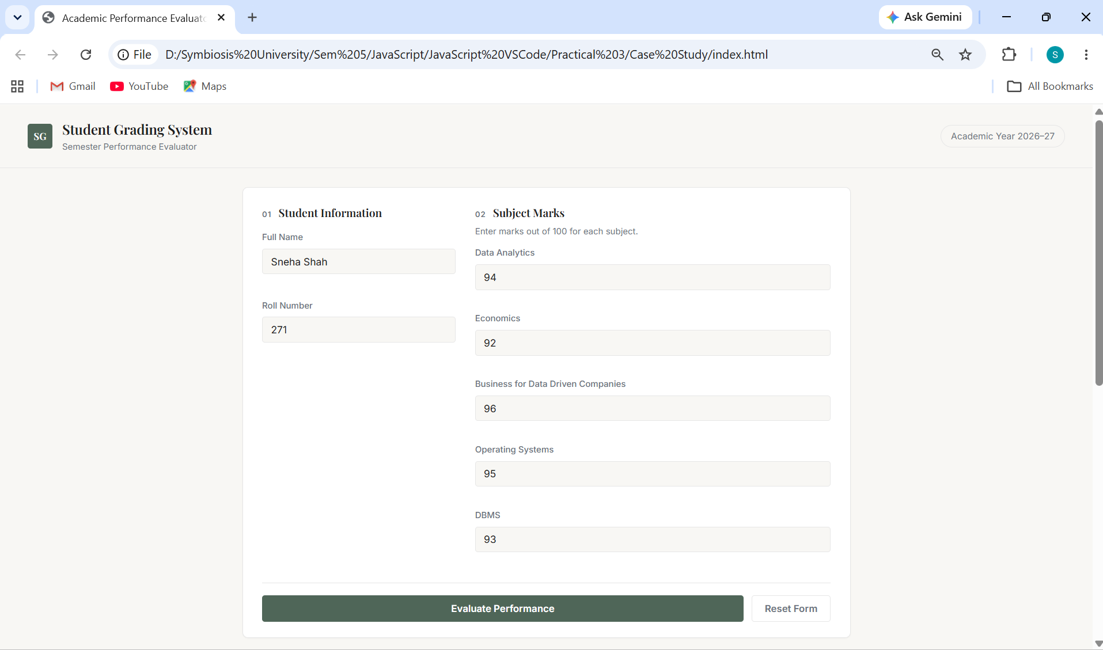

24070521271_SnehaShah

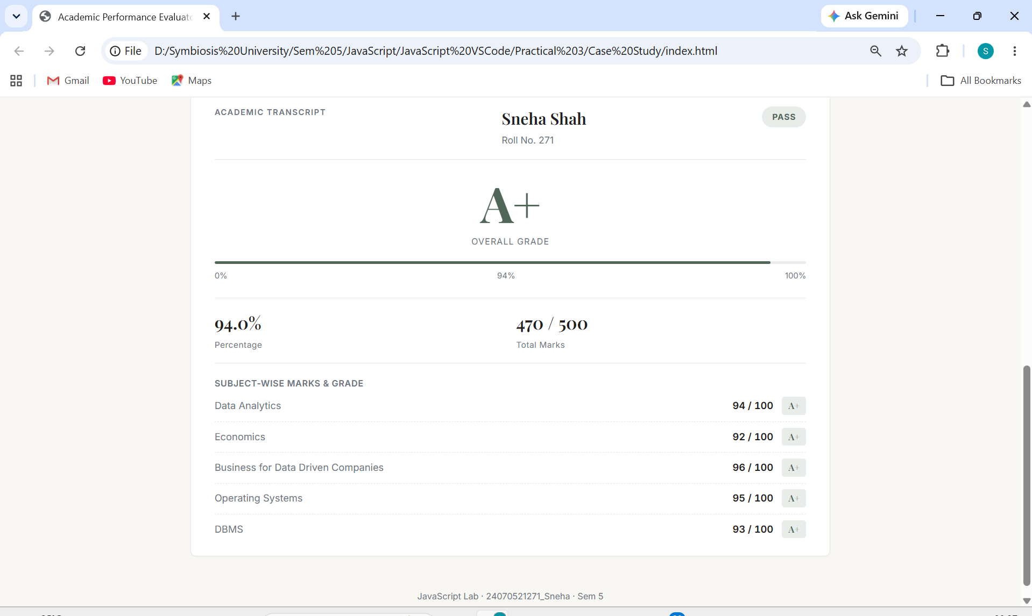

Additional Task:
24070521271_SnehaShah
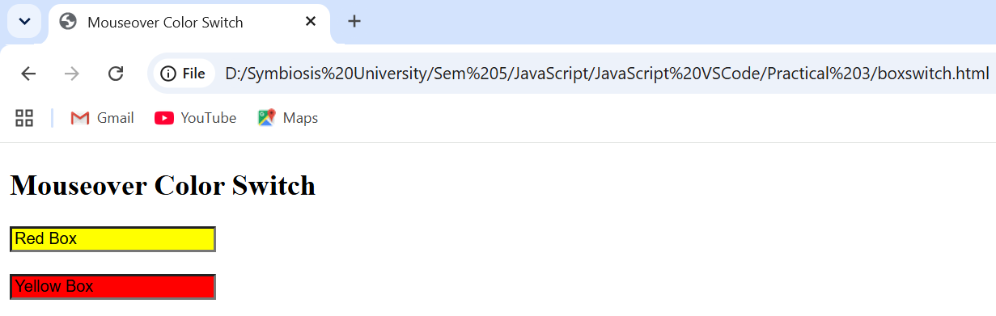
Conclusion: This experiment demonstrated the use of JavaScript control structures, loops, and form validation by creating a Student Grading System.

